BCT PRACTICAL-4
Addstudent function (Adding function to the array)
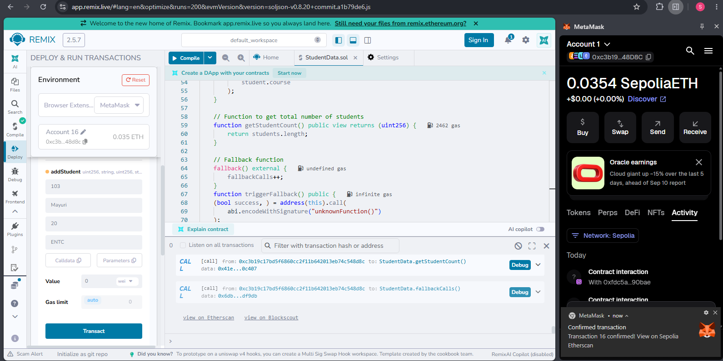

Fallback function


